Swayam Deeksha R B
1RUA24BCA0090

PHASE 1: UNDERSTANDING AGILE MANIFESTO
Step 1: Study Agile Manifesto Values
- Write one example where a traditional software development approach does not support Agile Manifesto Values and one example showing how Agile addresses this limitation.

  - Individuals and interactions over processes and tools
    - Traditional Approach: In Waterfall, communication is often formalized through rigid documentation, status reports, and tool-driven workflows. Developers may have limited direct interaction, relying instead on prescribed processes.
    - Agile Approach: Agile encourages daily stand-ups, pair programming, and open collaboration. For example, a Scrum team discusses blockers face-to-face rather than waiting for a weekly report, ensuring faster resolution.

  - Working software over comprehensive documentation
    - Traditional Approach: Waterfall emphasizes extensive upfront documentation (requirements, design specs) before coding begins. This can delay delivery of usable software for months.
    - Agile Approach: Agile delivers working increments quickly. For instance, a team releases a functional prototype after two sprints, allowing stakeholders to test features early instead of waiting for a fully documented design.

  - Customer collaboration over contract negotiation
    - Traditional Approach: In Waterfall, customer involvement often ends after requirements are signed off. Any change requires formal contract renegotiation, slowing progress.
    - Agile Approach: Agile involves customers continuously. For example, in Scrum reviews, customers provide feedback on each sprint’s deliverables, shaping the product iteratively without renegotiating contracts.

  - Responding to change over following a plan
    - Traditional Approach: Waterfall locks requirements early. If market needs shift mid-project, adapting requires costly rework and delays.
    - Agile Approach: Agile embraces change. For example, if a competitor launches a new feature, the product backlog can be reprioritized, and the team adjusts in the next sprint to deliver competitive functionality.

Step 2: Study Agile Principles
- Write one practical implication (how it affects daily project work) for Manifesto Principles.

  - Early & Continuous Delivery
    - Teams release small usable features early, so daily work focuses on building and testing increments quickly.

  - Welcoming Changing Requirements
    - Developers adapt to new priorities, often revising backlog items or refactoring code during sprints.
  - Frequent Delivery of Working Software
    - Regular releases mean daily coding must be production-ready, supported by automated testing and integration.

  - Collaboration Between Business & Developers
    - Daily work includes direct discussions with stakeholders to clarify needs and align technical tasks with business goals.

  - Working Software as Progress
    - Progress is shown through usable features, so developers prioritize coding and demos over lengthy documentation.

  - Continuous Improvement Through Reflection
    - Retrospectives drive changes, so teams adjust workflows, coding practices, or communication based on feedback.

PHASE 2: MAPPING AGILE PRINCIPLES TO PRACTICES USING TAIGA
Step 4: Identify Agile Practices
- Mention which Agile principles does the below mentioned Agile practices imply.

  - User Stories for Requirements → Support customer collaboration over contract negotiation by capturing needs in user focused language.

  - Prioritized Product Backlog → Embody welcoming changing requirements by keeping the most valuable work visible and adaptable.

  - Sprint-Based Development → Implement delivering working software frequently through short, iterative cycles.

  - Continuous Feedback → Enable business and developers working together daily by aligning progress with stakeholder input.
  - Team Collaboration → Reflect building projects around motivated individuals by fostering trust and shared ownership.

  - Retrospectives → Practice regular reflection to improve effectiveness by adapting processes for continuous improvement.

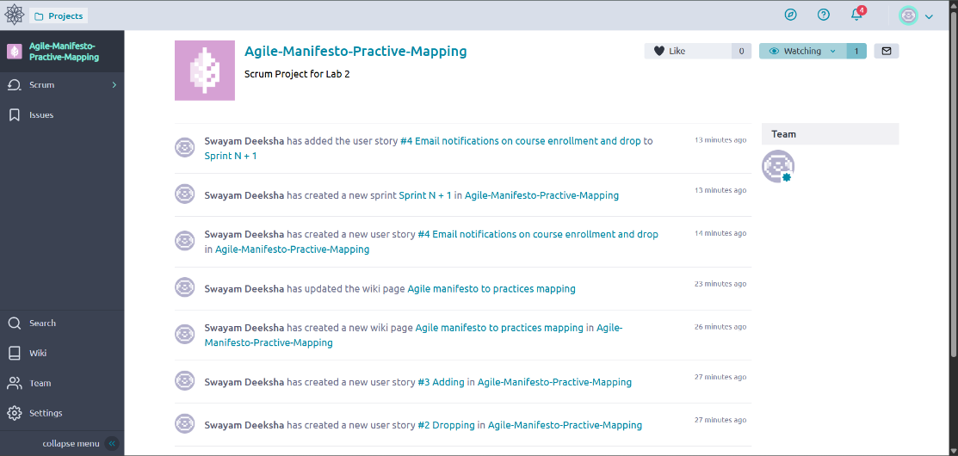
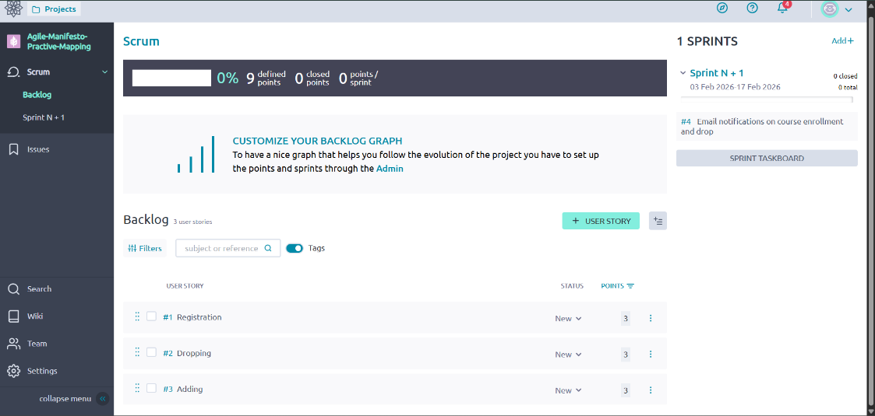
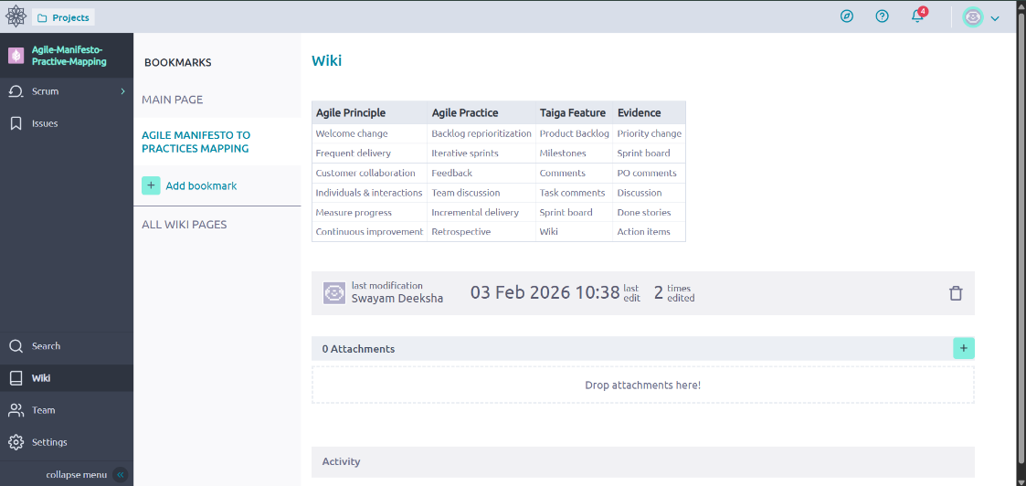

Step 8: Reflection Questions
- Which Agile principle was easiest to implement using Taiga?

  - “Working software over comprehensive documentation” and “Responding to change over following a plan” are easiest to implement.
  - Taiga’s Kanban boards, sprint planning, and backlog management make it simple to visualize tasks, track progress, and adapt priorities quickly.
  - Example: Moving a user story from Backlog → Sprint → In Progress → Done directly reflects Agile’s emphasis on delivering value iteratively.

- Which principle was difficult to represent using a tool?

  - “Individuals and interactions over processes and tools” is the hardest to capture.
  - While Taiga supports communication (comments, mentions, notifications), genuine collaboration and trust-building happen outside the tool—through conversations, retrospectives, and team culture.
  - Tools can facilitate but not replace human dynamics.

- How does Taiga support collaboration and transparency?

  - Collaboration:
    - Shared boards for tasks and sprints.
    - Real-time updates and notifications.
    - Comment threads on user stories and issues.
  - Transparency:
    - Clear visibility of backlog, sprint progress, and burndown charts.
    - Role-based permissions ensure everyone sees the same project status.
    - Metrics like velocity and cumulative flow diagrams make progress measurable and open.

- Can Agile values exist without tools? Justify.

  - Yes, Agile values can exist without tools.
  - Agile is fundamentally about mindset and principles, not software.
  - Teams can practice Agile with sticky notes on a wall, daily stand-ups, and retrospectives—no digital platform required.
  - Tools like Taiga enhance scalability, remote collaboration, and tracking, but they are enablers, not prerequisites.
  - The essence of Agile lies in communication, adaptability, and customer focus, which can thrive even without technology.

